SOFTWARE REQUIREMENT SPECIFICATION

|  |  |
| --- | --- |
| **Name** | BHARATHWAJ S |
| **Roll no** | 7376231CS503 |
| **Project Id** | 16 |
| **Project Name** | Internship Course Exemption |

# INTRODUCTION

# This document outlines the requirements for an Internship Course Exemption Portal (ICE Portal) It will explain the purpose and features of the system, the interfaces of the system, what the system will do, the constraints under which it must operate and how the system will react to external stimuli.

# PROBLEM STATEMENT

The ICE Portal caters to two user roles:

* **Student:** Students can apply for internship exemptions by submitting details and tracking the application status.
* **Admin:** Admins review applications, verify internship details, approve/reject exemptions, and manage reward options (optional).

# TECHNICAL REQUIREMENTS

|  |  |
| --- | --- |
| **COMPONENT** | **TECH STACK** |
| Frontend | React JS |
| Backend | Spring boot java |
| Database | MySQL |

**1.2.PRODUCT FUNCTIONS**

1.2.1 **User Registration**

* Students and admins can create accounts by providing necessary information.
* The system validates and stores user data securely.

1.2.2 **User Login**

* Users can log in using their credentials (username and password).
* The system authenticates users and assigns roles (student or admin).

1.2.3 **Password Management**

* Users can reset forgotten passwords via email verification.
* The system enforces strong password policies.

**2.STUDENT FUNCTION**

2.1 **Internship Application Submission**

* Students can submit internship applications by providing:
  + Company name
  + Internship duration
  + Supervisor details
  + Internship description
  + Uploaded supporting documents (e.g., offer letter)

2.2 **Application Tracking**

* Students can view the status of their internship applications (e.g., pending, approved, rejected).
* The system sends notifications to students about the status changes.

2.3 **Certificate Submission**

* After completing the internship, students can upload their internship completion certificates.
* The system stores and tracks the status of certificate submissions.

2.4 **Reward or Course Exemption Selection**

* Students are presented with options to select a reward or course exemption after certificate validation.
* The system records and processes the student's choice.

**3.ADMIN FUNCTION**

3.1 **Application Review and Approval**

* Admins can view and manage submitted internship applications.
* Admins can approve or reject applications, providing feedback if necessary.
* The system notifies students about the decision.

3.2 **Certificate Validation**

* Admins can review and validate submitted internship completion certificates.
* The system tracks the validation status and updates students accordingly.

3.3 **Scheduling and Management**

* If a student selects course exemption, admins can schedule interviews.
* The system sends notifications to students about interview details.
* Admins can record interview outcomes in the system.

3.4 **Final Approval and Processing**

* Admins finalize the reward or course exemption based on the student's choice and interview results.
* The system updates the student's academic records or processes the reward accordingly.

**4.GENERAL FUNCTION**

4.1 **Dashboard**

* Both students and admins have access to personalized dashboards.
* The student dashboard displays:
  + Internship application status
  + Certificate submission status
  + Reward/course exemption options
* The admin dashboard displays:
  + Pending internship applications
  + Submitted certificates
  + Scheduled interviews

4.2 **Reporting**

* Admins can generate reports on internship applications, approvals, and course exemptions.
* The system provides data export functionality for reporting purposes.

# 5.LOGOUT

* + - Users log out of the portal to maintain data security. The system automatically times out after a period of inactivity.

**STUDENT VIEW FLOW CHART**

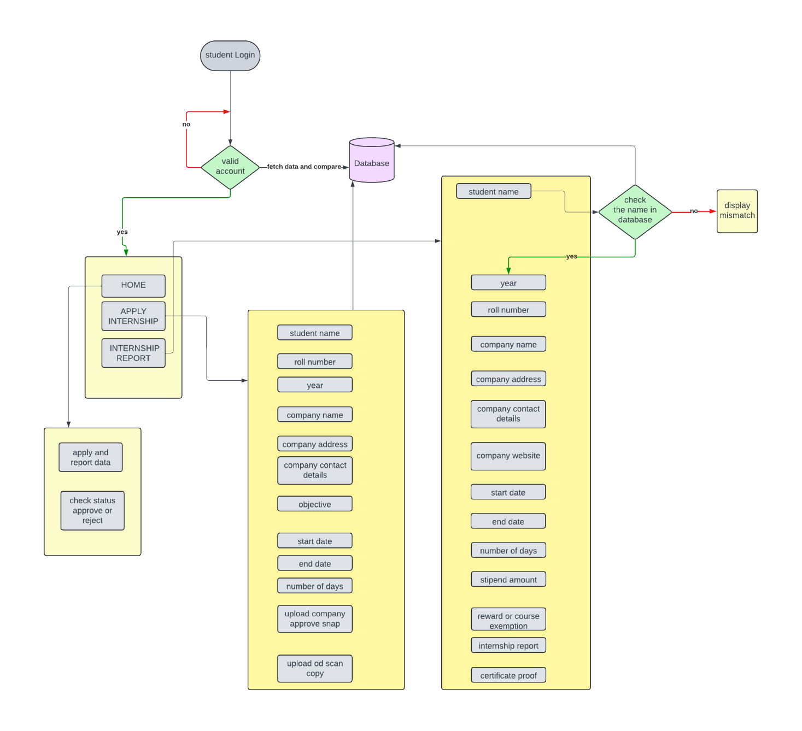

**ADMIN VIEW FLOWCHART**

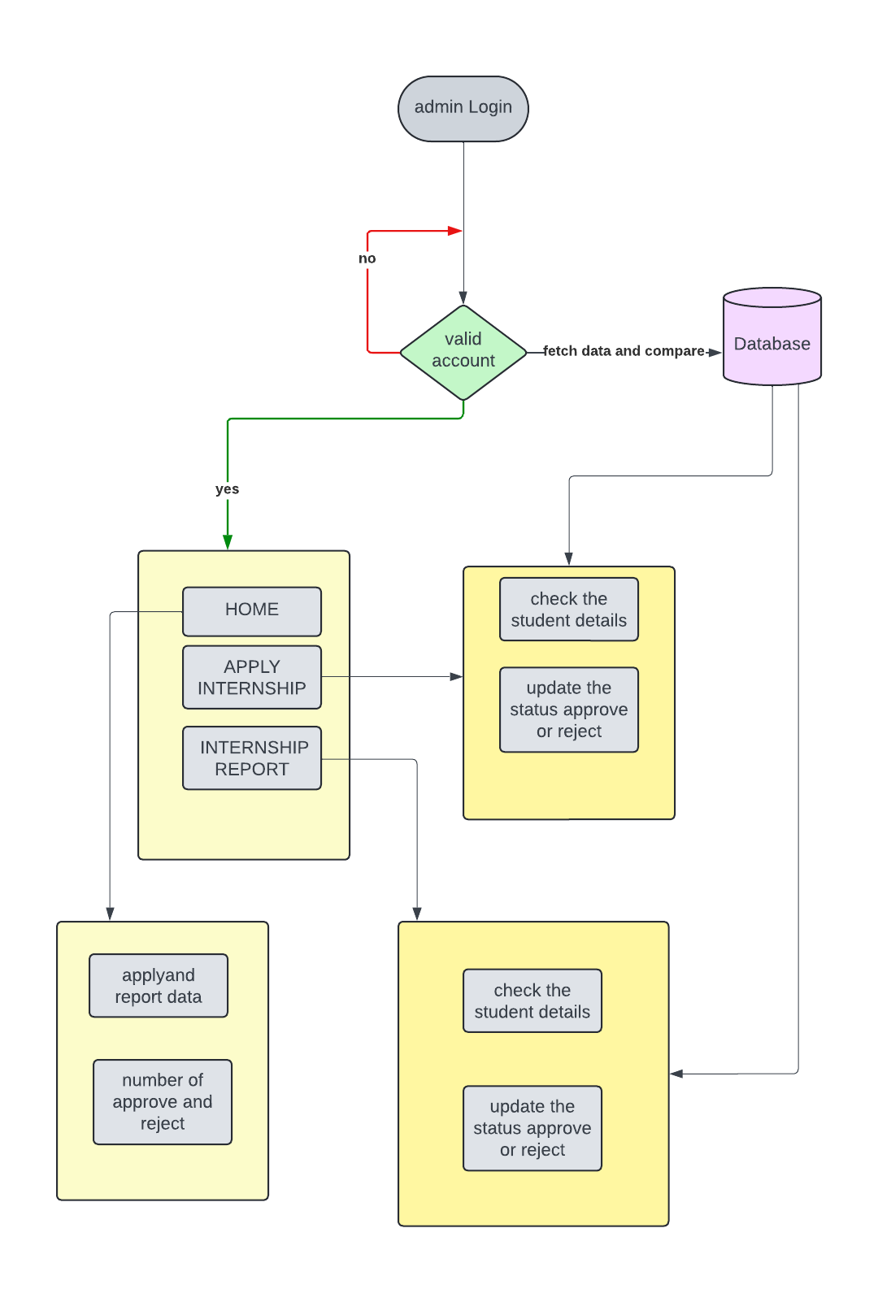

**ER DIAGRAM:**

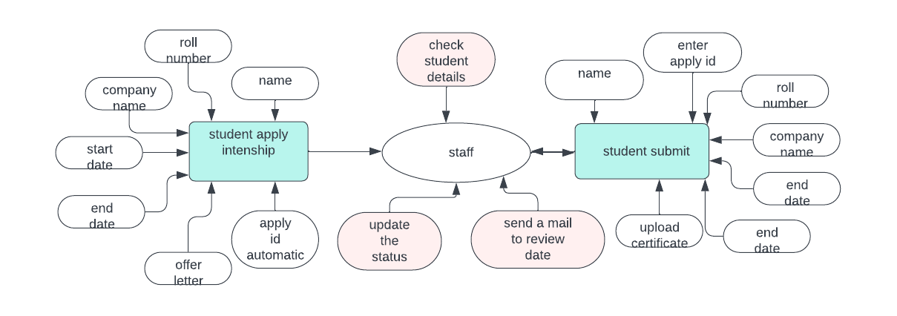

**LOGIN FORM:**

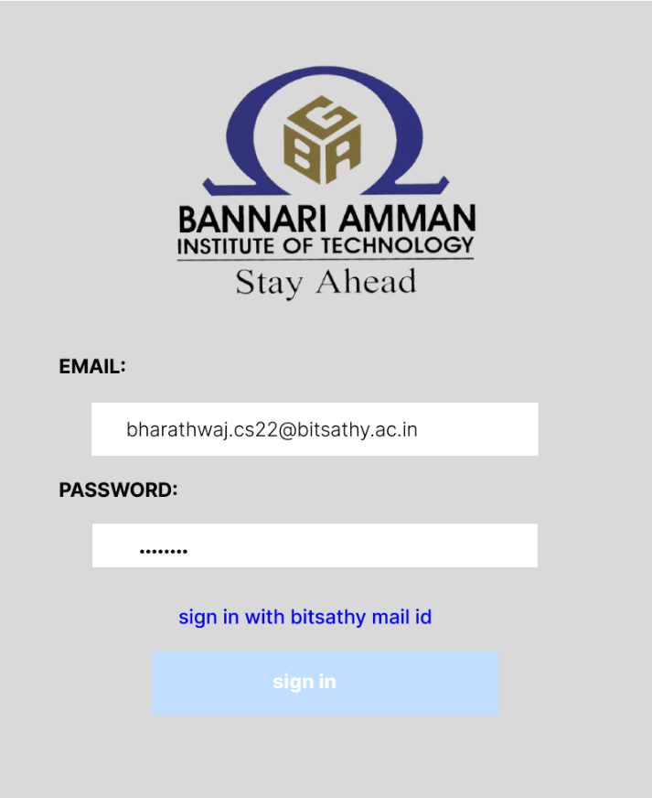

**STUDENT HOME PAGE:**

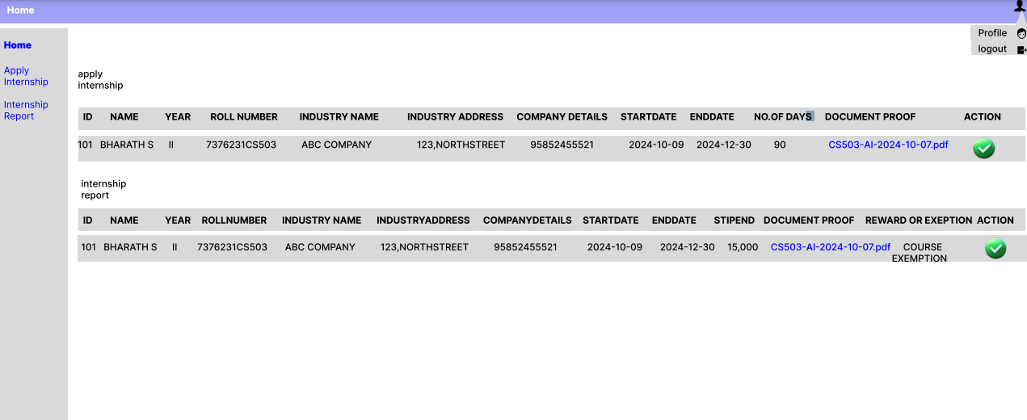

**APPLY INTERNSHIP:**

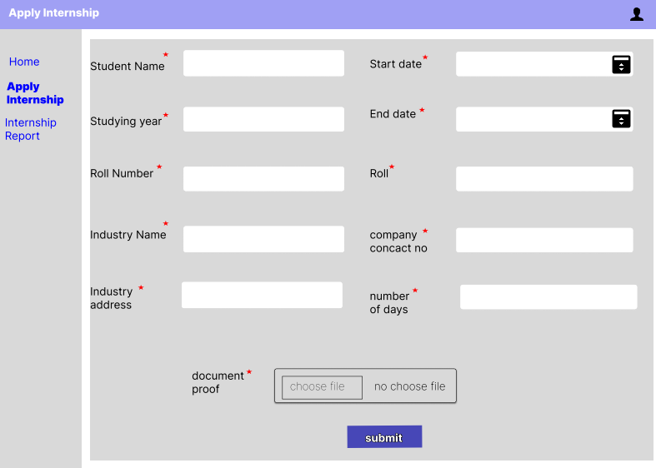

**INTERNSHIP REPORT:**

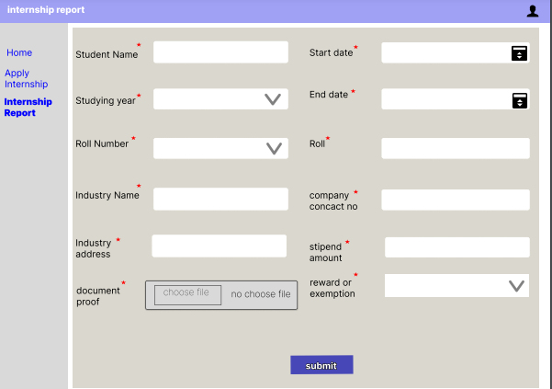

**ADMIN VIEW:**

